Here is some detailed feedback for each site individually:

https://www.allautonetwork.com/previews/Ferrari_Purosangue_3/index_cauley_v3.html

- We need to move the title in the hero over to the left to not block the vehicle.
- The hero video has a very “sudden” restart, is there a way to make it not so noticeable?
- Please remove the image here: The background can just be black.
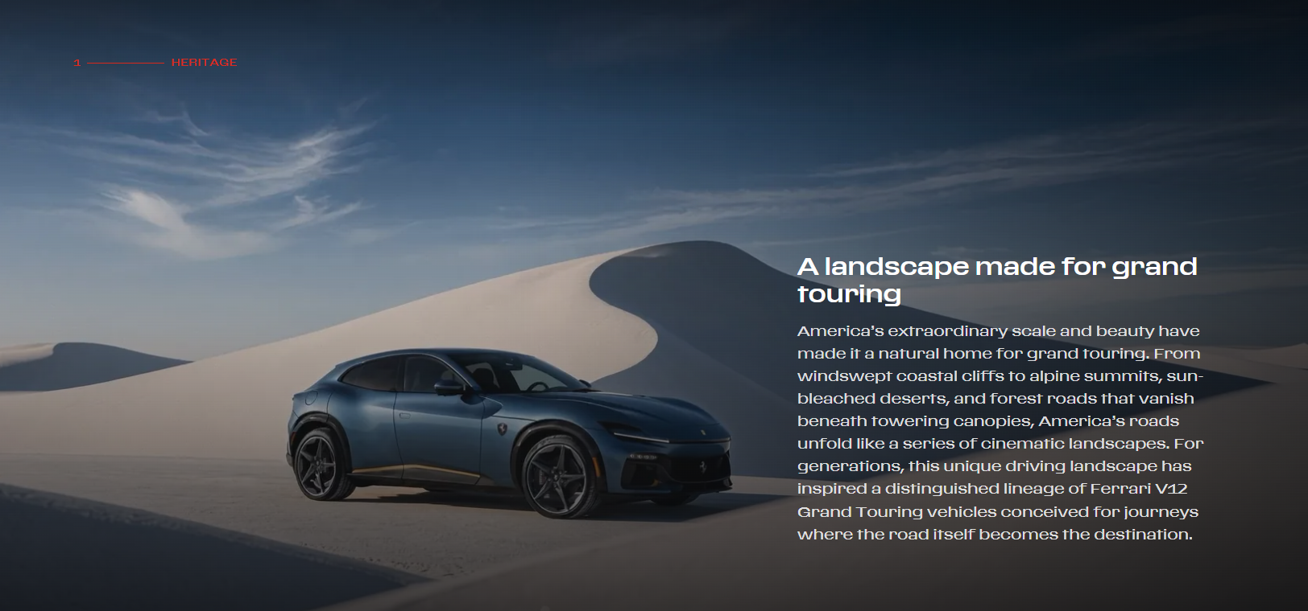
- Let’s remove the Exterior, Livery, and Interior callouts below the description.
- Are we able to make this similarly to this? With the photos side by side and the description below?
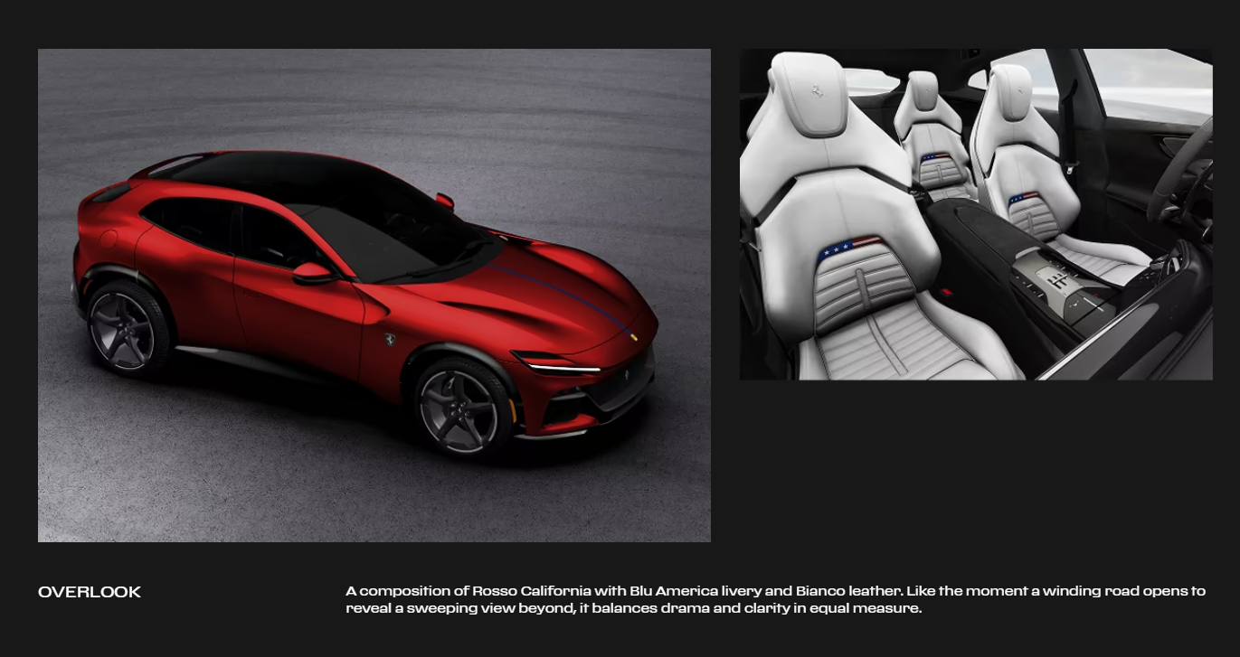

- You would then be able to remove “The Gallery” section

https://www.allautonetwork.com/previews/Ferrari_Purosangue_3/index_greenwich_v3.html

- The hero video should be “The Sands 02- Conform
- The hero video has a very “sudden” restart, is there a way to make it not so noticeable?
- Please remove the image here: The background can just be black.
- Let’s remove the Exterior, Livery, and Interior callouts below the description.
- Are we able to make this similarly to this? With the photos side by side and the description below?

- You would then be able to remove “The Gallery” section

https://www.allautonetwork.com/previews/Ferrari_Purosangue_3/index_lasvegas_v3.html

- The hero video should be “The Sands 02- Conform
- The hero video has a very “sudden” restart, is there a way to make it not so noticeable?
- Please remove the image here: The background can just be black.
- Let’s remove the Exterior, Livery, and Interior callouts below the description.
- Are we able to make this similarly to this? With the photos side by side and the description below?

- You would then be able to remove “The Gallery” section

Please let me know if you want to hop on a call to review!

